KiCAD Filter model updates March 21st, 2022

Job Summary:

I’m hoping that Kristian Jordan can make a few updates to the design of filterboards and motherboards. The main changes desired relate to keeping signals differentially paired, and not having the negative pairs grounded on the board.

Job Details:

1. The output connector, which was previously changed to a 68 pin VHDCI just like the input, also needs to have negative pairs passed through as an option. The pin numbers need to match the input VHDCI, even though this will necessitate a large number of overlapping traces and vias. Previously I thought it would be acceptable to switch them, but I was incorrect.
2. 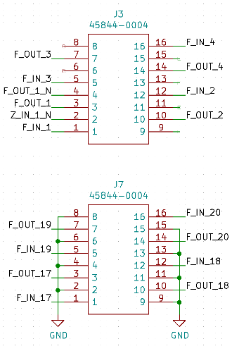**The daughter boards must be modified so that each channel’s paired negative signal is used as ground, and passed through to output. I’ve already made this change in the schematic for channel 1:**

See Z_IN_1_N goes to pin 2 instead of GND ->

Not like this ->

1. The daughter boards still have two inner ground planes, these need to ground through a 10M resistor to one of the negative input signals.
2. The motherboards need a number of connectors added:
   1. Between the filter boards and the output, the positive signals should go through a jumper **(0.1” header 2x32)** so that they can be interrupted if desired. **Please arrange these all in a row so that a 2x32 header array can be used. Feel free to increase board size.**
   2. Similarly, the negative signals should go to the center of a 3 pin header, so that they can either be grounded or passed along to the output VHDCI. This means a **large 3x32 header including all 32. Please arrange all in a row, increase board size in vertical direction so 68 pin connectors are farther from each other.**
   3. After the jumpers, before the output VHDCI, the signals should go to a u.FL pickoff, positive on the center pin, negative on the outer shield. **Leave a little more space for these, the wires come out sideways, and make sure they are in order. 4x8 is okay, but must go 1,2,3,4 in one row not 2,1,4,3.**
   4. Positive **Output** Pins 1-25 **should also go to a DB25 connector**, as they used to in the older version of the motherboard. **This connector should be added after all the jumpers, close to the output VHDCI68 connector.**
3. The motherboards also need all RC filters removed.
4. All gerbers, and assy files (BOM, centroid, paste, assy drawing) need to be re-generated.

Motherboard Schematic for the 1st Channel:

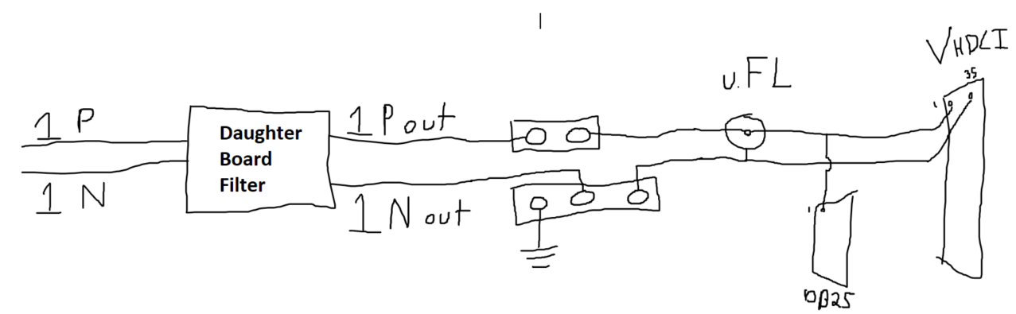

Part List: (still needs some updating!)

1. Motherboard:
   1. A31814-ND, HD68 connector, J1, J2
   2. WM7543-ND, board edge connector, J3-10
   3. RMCF0603ZT0R00CT-ND , R1-6, 13-18, 25-30, 39-44, 51-56, 63-66, 71,72: 0 ohm
   4. All other R’s, do not place.
   5. All C’s: do not place.
2. Daughterboard OLD:
   1. H11891TR-ND, u.FL connector
   2. 587-2511-1-ND, PI filter inductor, L1
   3. 311-69.8HRCT-ND, R2, 70 ohm
   4. 399-C0603C222J2GAC7867CT-ND, C2-3, 22n 100V NP0 0603
   5. RMCF0603ZT0R00CT-ND, R3, L2, 0 ohm
   6. C1, 587-6323-2-ND
   7. R1, do not place
   8. Same for other four filters.
3. Daughterboard NEW:
   1. RMCF0603JJ1K00TR-ND, R1,2,3,4: 1k
   2. 587-6323-2-ND, C1,2,3,4: 0.1u